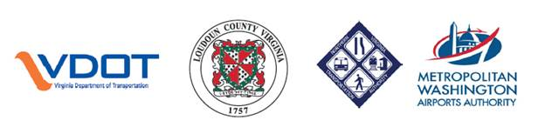

|  |  |  |
| --- | --- | --- |
| **RELEASE:** | Immediate | Sept. 6, 2017 |
| **CONTACT:** | Jennifer McCord, VDOT 571-230-2926  [jennifer.mccord@vdot.virginia.gov](mailto:jennifer.mccord@vdot.virginia.gov)  Sarah Camille Hipp, NVTA 571-355-4461 [sarahcamille.hipp@thenovaauthority.org](mailto:sarahcamille.hipp@thenovaauthority.org) |  |
|  |  |  |

**LOUDOUN COUNTY PARKWAY IMPROVEMENTS CELEBRATED***Parkway extension and new intersection at Old Ox Road open to traffic tonight*

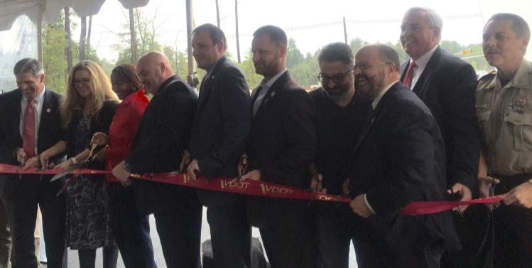**ARCOLA** – Important transportation improvements open to drivers today, as the Virginia Department of Transportation, Loudoun County, the Northern Virginia Transportation Authority, and the Metropolitan Washington Airports Authority recognized the joint effort to achieve several milestones at an event on the Loudoun County Parkway this morning.

* **A new, signalized intersection at** **Loudoun County Parkway and Old Ox Road** opens to traffic tonight. This is one element of the overall [VDOT-administered project](http://www.virginiadot.org/projects/northernvirginia/old_ox_road_widening.asp) that will also reconstruct and widen Old Ox Road from two to four lanes between Evergreen Mills to the Dulles Greenway (about five miles) and add a multi-use path. Shirley/Dewberry will complete the $119 million project in the summer of 2018.

The [Northern Virginia Transportation Authority](http://www.thenovaauthority.org/) provided $31 million in funding toward this intersection and additional improvements for the Loudoun County Parkway corridor. VDOT, Loudoun County and MWAA [are jointly funding](http://www.virginiadot.org/newsroom/northern_virginia/2013/governor_mcdonnell_announces_vdot68955.asp) the Old Ox Road reconstruction and widening. MWAA contributed up to 40 acres of land for the widening.

* Just to the north, **a new one-mile extension of the Loudoun County Parkway from Broad Run to Creighton Road** also opens, built by developer Brambleton under County proffer. It also includes a recently completed segment of **Shreveport Drive, connecting Belmont Ridge Road to the Parkway, with two new signals** at the Parkway and at Belmont Ridge Road.   
    
  An additional segment of theLoudoun County Parkway to the north, from Evergreen Ridge to Creighton Road, was built by Toll Brothers and opened in 2016.

“Together, these improvements are expected to provide much-needed congestion relief and alternative routes to commuters in the Dulles and Ashburn areas of Loudoun,” said VDOT Northern Virginia District Construction Engineer Bill Cuttler. “The intersection opening is significant, as it connects drivers from Route 50 all the way to Route 7, critical for motorists from points west accessing Leesburg, Ashburn, Sterling and Herndon.”

“Relieving congestion for roadways like these is an integral part of our goal to improve quality of life throughout the Northern Virginia region,” said Martin E. Nohe, Chairman of Northern Virginia Transportation Authority and Coles District Supervisor for Prince William County. “NVTA is excited to be part of this new connection and the future improvements along Old Ox Road.”  
  
"The Airports Authority is proud to be part of this important roadway project that will improve capacity of Route 606, providing convenient access to, from and around Dulles International Airport," said Jack Potter, President and CEO of the Metropolitan Washington Airports Authority.   
  
**Follow VDOT Northern Virginia on Twitter:** [@vadotnova](https://twitter.com/vadotnova)

END